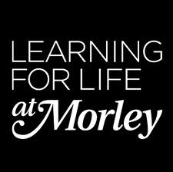
Educate Out Prejudice Curriculum Pilot
Embedding LGBT - GCSE English - Catherine O’Shea
Contents:
- Lesson Plan (pp. 2 – 5)
- Group Profile with Equality and Diversity Statement (pp. 6)
Resources (pp. 7 – 16)
The creation of this material by Morley College has been financed by the Skills Funding Agency Equality and Diversity Innovation Fund 2013/14.Copyright in this material is vested in the Crown but it is made freely available through an Open Government Licence. This licence enables you to use and adapt the material but you must attribute Morley College as the creator and include details of the licence. Full details of the licence are available at http://www.nationalarchives.gov.uk/doc/open-government-licence/

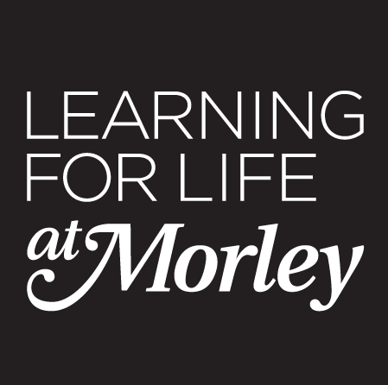 LESSON PLAN Essential Skills 2013-2014

COURSE TITLE: GCSE English  COURSE CODE: FEK005A |  | TUTOR  Catherine O’Shea | WEEK NO  8 | DATE OF LESSON  6/3 | NO. OF LEARNERS  14
LEARNING OUTCOMES  (What the student will know or be able to demonstrate by the end of the session) | By the end of the session students will be able to:  1. Identify the types of questions on the reading and writing exam.  2. Implement exam strategies for answering Questions 1, 2 and 3.  3. Discuss issues facing LGBT communities.

TIME | PURPOSE  (stage of lesson and learning outcome it links to) | LEARNER AND TEACHER ACTIVITY | DIFFERENTIATION/DIVERSITY* | ASSESSMENT OF LEARNING  (How will students’ progress in the lesson be assessed?) | RESOURCES
10 min | Focus – Recap. | Q and A: What are the six types of questions on the reading and writing exam?  Refer to AQA breakdown from AQA website.  What are the key exam strategies?  Students add information to six big sheets of paper (Questions 1-6 | Differentiate students arranged in small groups based on ability. | Group feedback. | Hand out large sheets of paper (A2)  AQA exam website material.
10 min | How to answer Question 1: Reading. | What is a summary? How do you summarize an article?  How would you summarize your day?  Ask for students to summarize there day for the class.  What is the last film you watched? Summarize to your partner.  Question 1 will be something like ‘What do you learn from the article’. | Relate films to equality and diversity themes where suitable. | Q and A
20 min | How to answer Question 1: Reading. | Hand out Source 1* – Article about the boycott of the Sochi Olympics.  What is skimming and scanning?  Students have a set time to read the article, underlining and highlighting the key points.  Students have to verbally summarize the article to their partner. | Rearrange the students in differentiated pairs.  Pair non-native and native English speakers.  Dyslexic student will have more reading time in the exam. | Move around the pairs and listen to their summaries. | Source 1 copies.
10 min | How to answer Question 1: Reading. | With your partner produce a list of bullet points to summarize the article.  Include one point which summarises the purpose, one that that explains the topic and a few interesting quotes and statistics. | From Source 1 – a pair and class discussion of how LGBT people are treated in Russia and celebrity protests. | Feedback lists to the room. | Source 1 copies.
15 min | How to answer Question 2: Reading. | Question 2 will be about linking the picture/heading/headline to the text.  Hand Source 2 to half the pairs. The pairs with the picture have to describe the image to another pair. The pairs without the image have to try and replicate the picture only based on the description.  Focus on using descriptive writing and fully explaining what the picture shows. | What does the symbol of the rainbow flag mean? |  | Source 2 copies.  Paper and coloured pens.
10 min | How to answer Question 2: Reading. | Why has this image been chosen? What does it represent?  Find three quotes in the article that link directly to the picture.  Use Point, Evidence, Explain to explain why the picture and text link. | Challenges facing the LGBT community. | Class discussion. | Source 2 copies.
15 min | How to answer Question 3: Reading. | Source 3 (Stephen Fry blog post) – recap Sochi Olympics discussion.  Students read article.  Question 3 is about language. Our mock question is ‘How does language in Source 3 show us the writer’s thoughts and feelings’.  Underline the adjectives in this writing.  Students write up an adjective on the interactive whiteboard. | Stephen Fry’s letter protesting about treatment of LGBT people in Russia.  Comparisons to anti-Semitism.  What are your ‘thoughts and feelings’ on this topic? |  | Source 3 copies.
20 min | How to answer Question 3: Reading. | Look for rhetorical and linguistic devices, metaphor, imagery, persuasive writing.  Give each group a task to find examples of a device. | Arrange students in new groups based on confidence with linguistic terms. | Quick group presentation to link linguistic device to a thought/feeling. | Source 3 copies.
10 min | Mock paper. | Review of Questions 1-3. Look at the mock exam paper. Questions 1-6 on Sources 1, 2,3.  Each student say one thing you have learned from today’s lesson. | Awareness of E and D in what students have learned. | Directed questioning | Mock exam papers.
*How will your lesson take account of different learning needs, learning styles and abilities/levels? How will it support and promote E and D? For example: Gender, Race, Disability, Cultural and ethnic b/ground, sexual orientation?

EVALUATION OF LESSON (Were the learning outcomes achieved? What was successful? What could be improved? Is there anything that needs to be carried over to the next session?)

The students have been doing practice exam papers all year for their GCSE English 4700 exam. I presented this as another exam paper. I did not draw particular attention to the LGBT themes as I think it is important that equalities themes are presented in the same way as any other texts. I wanted to present the 3 articles in the same way as any regular text we might use in class. I did not start with a specific focus on LGBT issues and I found it useful to simply embed a text with equalities awareness in this way.

6/3 GCSE Lesson (2 hours) – The students had thoughtful and interesting responses. They were engaged in the topic and the articles. They found these articles more interesting than some of the past papers. It was a large amount to read at this level and served as a useful reading exercise for exam practice.

Many of the students did not know that a rainbow flag was associated with homosexuality. As a group they had many differing and interesting ideas on what the image on the Source 2 article represents.

The students finished this material for homework. We then reviewed their answers and discussed their responses in the following session.

HOMEWORK

Spend 2 hours and 15 minutes in timed conditions completing the mock exam paper at home. Questions 1-4 (Reading) and Questions 5, 6 (Writing).
Use Sources 1, 2 and 3 from the lesson for this mock exam.

The creation of this material by Morley College has been financed by the Skills Funding Agency Equality and Diversity Innovation Fund 2013/14.Copyright in this material
is vested in the Crown but it is made freely available through an Open Government Licence. This licence enables you to use and adapt the material but you must attribute
Morley College as the creator and include details of the licence. Full details of the licence are available at http://www.nationalarchives.gov.uk/doc/open-government-licence/
Essential Skills 2013-2014

Group Profile with Equality and Diversity Statement

Course Title: GCSE English

Course Code: | FEK005A | Level | GCSE
Number on register | 14 | Tutor: C O'Shea
Comments on the group (issues which impact on the way you organise the group or plan your teaching, e.g. size, range of ability, mixture of beginners/experienced, any learning support needs or disabilities, range of ages, learning styles of students etc.)

In this group there are 14 students with a variety of needs. 10 of the students speak English as their first language; the other 4 speak Spanish, Polish and Oromo. The class has equal numbers of men and women. The age range is from 20 – 60. The students are mostly in full time employment and are permitted to leave work early to attend the class at 4pm. 4 of the students have additional support needs and attend learning support sessions. Two students are dyslexic and one student suffers from work related anxiety. There is a high level of ability and interest in the subject. Most of the students lack confidence in their own writing ability although they are set to achieve well.

Differentiation for this group based on the above

For this group it is necessary to constantly change pairings so that the range of abilities all work with different students. It is also necessary to have an extension or stretch activity for every task and to offer a range of activities on Moodle and to complete at home.
It is necessary to provide regular positive written feedback and to work with each student on having more confidence in their own ability. It is useful to pair ESOL students with native English speakers and to alternate groupings for discussion so those more comfortable with intellectual debate can help others.
Equality and Diversity and Safeguarding

I confirm that I will treat all students equally in this class and make sure that all students treat each other with respect. I will pay full attention to the welfare of my students and report any concerns to my line manager and the college.

Embedding LGBT - GCSE English – Resources.
- GCSE Mock Exam (pp.9)
- Source 1 - Lady Gaga urges Tom Daley Article (pp.10-11)
Online Source: Selby, J. (2013) Lady Gaga urges Tom Daley to boycott anti-gay countries ahead of Russia Winter Olympics, [Online], Available: http://www.independent.co.uk/news/people/news/tom-daley-urged-to-boycott-antigay-countries-by-lady-gaga-8988359.html [19 June 2014].
- Source 2 - Law-making Article (pp.12-13)
Online Source: Heshner, P. (2013) It takes more than law-making to shift cultural contempt towards gay people, [Online], Available: http://www.theguardian.com/commentisfree/2013/dec/13/law-making-cultural-contempt-gay-people-marriage [19 June 2014].

- Source 3 - An open letter to David Cameron and the IOC (International Olympics Committee) (pp.14-16)
Online Source: Fry, S. (2013) An Open Letter to David Cameron and the IOC, [Online], Available: http://www.stephenfry.com/2013/08/07/an-open-letter-to-david-cameron-and-the-ioc/#more-7437 [19 June 2014].

The creation of this material by Morley College has been financed by the Skills Funding Agency Equality and Diversity Innovation Fund 2013/14.Copyright in this material is vested in the Crown but it is made freely available through an Open Government Licence. This licence enables you to use and adapt the material but you must attribute Morley College as the creator and include details of the licence. Full details of the licence are available at http://www.nationalarchives.gov.uk/doc/open-government-licence/

GCSE English 4700 – Mock Exam
Spend 2 hours 15 min completing this mock exam.
Section A – Reading

- Read Source 1. Explain what you learn from Source 1. (8 marks)

- Read Source 2. How do the picture and the headline link to the text? (8 marks)

- Read Source 3. How does the writer use language to demonstrate their thoughts and feelings? (8 marks)

- Compare Source 3 to either Source 1 or 2. (16 marks)

Section B – Writing

- Write a blog entry about a time in your life where you were unfairly treated or discriminated against. (16 marks)

- Write an article for your school or college newspaper about bullying and discrimination in education. (24 marks)

Lady Gaga urges Tom Daley to boycott anti-gay countries ahead of Russia Winter Olympics
The singer, who herself is openly bisexual, praised the 19-year-old sportsman before launching into a tirade about the upcoming Winter Olympics
Jenn Selby
Friday, 6 December 2013
Lady Gaga is urging Tom Daley to boycott competing in countries that have strict anti-gay laws.
The singer, who herself is openly bisexual, praised the 19-year-old sportsman for his brave decision to come out this week, before launching into a tirade about the upcoming Winter Olympics in Sochi, Russia.
“I don’t think that we should be going to the Olympics at all,” she told Alan Carr on his Channel 4 show Chatty Man.
“I mean, I would never take anything away from [the athlete’s] hard work, I just think it is absolutely wrong for so many countries to send money and economy in the way of a country that doesn’t support gays.”
“They pepper spray and beat them in Russia,” she added.
Despite the fact that Daley, a diver, does not compete in the Winter Olympics, she continued: “It made me very sad to see the pain that some of the gay kids are in in Russia, and for the world to send their finest for the Olympics… I can’t, it just feels so wrong and sad. I hate saying that, because I’m so excited for those like Tom Daley to go and to win and to rejoice.”
Asked whether she would ever go back to the country for a visit, she said: “I don’t think I’m even allowed in anymore because I screamed ‘I’m gay, arrest me’ on stage last time I was there, so…”
Daley came out in a moving video message to fans earlier this week, admitting that he is currently in a relationship with a man. Since then, it has been reported that he is dating 39-year-old Hollywood screenwriter Dustin Lance Black.
He broke his silence on the romance during an interview on The Jonathan Ross Show.
“I’d never felt like anything like it before. We were at a party and I hadn’t even spoken to him all night. I didn’t know what to do or if he was gay at first,” he said.
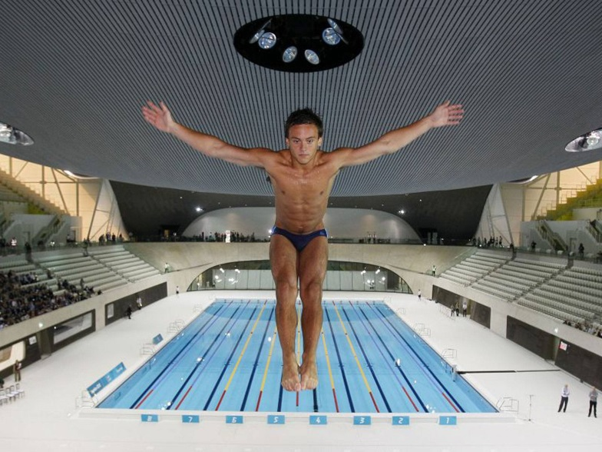

“I typed ‘call me’ in his notes with a smiley face on this phone and the next day he texted. He makes me feel safe and happy; right now I couldn’t be happier.
“I’d never felt the feeling of love, it happened so quickly, I was completely overwhelmed by it to the point I can’t get him out of my head all the time. I’ve never had it before where I love someone and they love me just as much.”
However, the Olympic diver, 19, stopped short of confirming – or denying – that the man he is in a relationship with is Black, 39. Asked why he had chosen not to identify his lover, Daley said: “At the moment, I wouldn’t like anything to change.
http://www.independent.co.uk/news/people/news/tom-daley-urged-to-boycott-antigay-countries-by-lady-gaga-8988359.html

It takes more than law-making to shift cultural contempt towards gay people
Gay marriage is sanctioned from next year and legal protections are mostly in place, but it may take another generation for minds to slowly change

  - Philip Hensher
  - The Guardian, Friday 13 December 2013 15.30 GMT

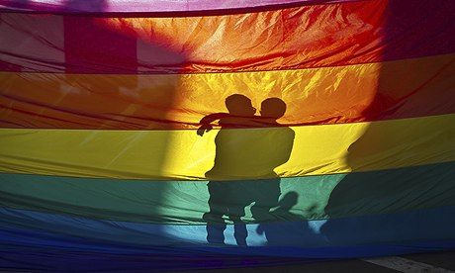
In the UK, 'the legal protections are all pretty much in place, and the principle of equality enshrined … The grounds are set for a small but emphatic backlash.' Photo: David Poller/Zuma Press/Corbis
Sometimes we forget that not all relations, not all behaviour in the past, were controlled and restrained by law, or needed to be. When vulnerable behaviour is protected by law, the role of personal decency starts to seem disposable. You've got the laws you asked for – why do you want people to be nice as well? Or, even worse – we're being nice to you because the law tells us to be. That's good enough, isn't it?
This may be the issue with the acceptability, or otherwise, of gay people in society. The legal protections are all pretty much in place, and the principle of equality enshrined. When same-sex marriages start taking place next March, we can work wherever we choose; hoteliers may not turn us away; we must be treated equally by the providers of goods and services. We must not be abused in the street on the grounds of our sexuality. You must be nice to us. It's the law.
The grounds are set for a small but emphatic backlash. It's easy to point to international examples, where individual jurisdictions have decided they want nothing to do with the general spread of liberalising legislation, and are going to make a stand. India's supreme court overturned a 2009 ruling decriminalising homosexuality, arguing that it was not an equality issue. An Australian court disallowed gay marriages, which had already taken place in the Australian Capital Territory. A referendum on gay marriage in Croatia produced a firm rejection. A ruling by the European court of human rights about gay marriage was rejected by Greece. Russia is enshrining prejudice and creating opportunities for physical violence against gay people through its laws. And so on.
It is easy to say that things are much easier in the UK, and the legal protections are now firmly in place. But the difference between anti-discrimination laws and a change in culture can make things less clear. A generation ago, people bemoaned the alteration in the meaning of the word "gay". Now, very similar people are discovering the virtues of semantic change and are firmly defending a shift in the sense of the word to mean "rubbish", in the face of a school playground campaign by Stonewall. When the diver Tom Daley came out, he hardly had a word to use of himself, as hundreds of other young gay people must be finding.
And the reaction to Daley's coming out showed an interesting cultural problem, not to be legislated against. There was a largely positive response; and there was also a banal online flurry of old-fashioned abuse. More interesting, however, was a widespread response that ran "Who cares? Why is this even news? Why are we hearing about this?"
For a standard response to shift from "We really don't want to hear about your disgusting private life" to "I'm too cool to want to hear about you being gay" is not much of an advance. At the last Olympics, 12,000 athletes included exactly three gay men who were out. Of course, Daley coming out was important news, for him and for the primitive culture of professional sport. To say "Why is this on the news?" is to demand silence from a minority.
Every gay person has examples of cultural contempt that no legal recourse can touch. Most people are reluctant to bring them up for fear of sounding petty. When I worked at the University of Exeter, every colleague who embarked on any step in the great journey of heterosexuality had it promptly marked with a general email from the administration about babies, engagements, weddings and so on. After my civil partnership, I had to ask a junior colleague to send a note round, and forever afterwards one administrator used to say "Your partner – oh, you like to call him 'your husband', don't you?" with a poisonous smile, as if it were a harmless eccentricity of my own that she might as well indulge.
Even to mention it seems petty; no legal sanction will touch, or ought to touch it. There's no law on earth to compel work colleagues to invite their gay team member out for a drink on Friday night, or to congratulate them on their marriage without making quotation marks in the air. Probably a generation or more will pass before such dismissive stereotypes stop being used in the most unlikely circumstances – once, I was discussing the marking of an MA thesis with a colleague at Exeter when another sailed past saying: "I can't think what you two queens are bitching about."
It's all on the way out: we are less likely to be beaten up than we would have been a generation ago, or if we were living in Russia. We probably have to resign ourselves to a generation of disadvantage – and the occasional, curious resurfacing of what never went away – while minds slowly change.

http://www.theguardian.com/commentisfree/2013/dec/13/law-making-cultural-contempt-gay-people-marriage

An Open Letter to David Cameron and the IOC
By Stephen Fry, August 7th, 2013.

Dear Prime Minister, M Rogge, Lord Coe and Members of the International Olympic Committee,
I write in the earnest hope that all those with a love of sport and the Olympic spirit will consider the stain on the Five Rings that occurred when the 1936 Berlin Olympics proceeded under the exultant aegis of a tyrant who had passed into law, two years earlier, an act which singled out for special persecution a minority whose only crime was the accident of their birth. In his case he banned Jews from academic tenure or public office, he made sure that the police turned a blind eye to any beatings, thefts or humiliations inflicted on them, he burned and banned books written by them. He claimed they “polluted” the purity and tradition of what it was to be German, that they were a threat to the state, to the children and the future of the Reich. He blamed them simultaneously for the mutually exclusive crimes of Communism and for the controlling of international capital and banks. He blamed them for ruining the culture with their liberalism and difference.

The Olympic movement at that time paid precisely no attention to this evil and proceeded with the notorious Berlin Olympiad, which provided a stage for a gleeful Führer and only increased his status at home and abroad. It gave him confidence. All historians are agreed on that. What he did with that confidence we all know. Putin is eerily repeating this insane crime, only this time against LGBT Russians. Beatings, murders and humiliations are ignored by the police. Any defense or sane discussion of homosexuality is against the law. Any statement, for example, that Tchaikovsky was gay and that his art and life reflects this sexuality and are an inspiration to other gay artists would be punishable by imprisonment. It is simply not enough to say that gay Olympians may or may not be safe in their village.

The IOC absolutely must take a firm stance on behalf of the shared humanity it is supposed to represent against the barbaric, fascist law that Putin has pushed through the Duma. Let us not forget that Olympic events used not only to be athletic, they used to include cultural competitions. Let us realise that in fact, sport is cultural. It does not exist in a bubble outside society or politics. The idea that sport and politics don’t connect is worse than disingenuous, worse than stupid. It is wickedly, wilfully wrong. Everyone knows politics interconnects with everything for “politics” is simply the Greek for “to do with the people”.

An absolute ban on the Russian Winter Olympics of 2014 on Sochi is simply essential. Stage them elsewhere in Utah, Lillehammer, anywhere you like. At all costs Putin cannot be seen to have the approval of the civilised world. He is making scapegoats of gay people, just as Hitler did Jews. He cannot be allowed to get away with it. I know whereof I speak. I have visited Russia, stood up to the political deputy who introduced the first of these laws, in his city of St Petersburg. I looked into the face of the man and, on camera, tried to reason with him, counter him, make him understand what he was doing. All I saw reflected back at me was what Hannah Arendt called, so memorably, “the banality of evil.” A stupid man, but like so many tyrants, one with an instinct of how to exploit a disaffected people by finding scapegoats. Putin may not be quite as oafish and stupid as Deputy Milonov but his instincts are the same. He may claim that the “values” of Russia are not the “values” of the West, but this is absolutely in opposition to Peter the Great’s philosophy, and against the hopes of millions of Russians, those not in the grip of that toxic mix of shaven headed thuggery and bigoted religion, those who are agonised by the rolling back of democracy and the formation of a new autocracy in the motherland that has suffered so much (and whose music, literature and drama, incidentally I love so passionately). I am gay. I am a Jew. My mother lost over a dozen of her family to Hitler’s anti-Semitism. Every time in Russia (and it is constantly) a gay teenager is forced into suicide, a lesbian “correctively” raped, gay men and women beaten to death by neo-Nazi thugs while the Russian police stand idly by, the world is diminished and I for one, weep anew at seeing history repeat itself.

http://www.stephenfry.com/2013/08/07/an-open-letter-to-david-cameron-and-the-ioc/#more-7437

